SPORT 1ST AID SUPPLIES CATALOG
On the following pages you will find a listing of all 1st Aid Supplies that we have for sale. Reference this catalog to help make ordering easier.
To order supplies, you must fill out an order form also located on our website www.smscs.ca under 1st Aid Sales drop down. Once you have utilized this catalog to reference your order please email it to s.jule@sasktel.net. The listing of the supplies in the two documents are arranged in the same order for easier use. We will contact you for payment once your order has been approved.

2205 Victoria Ave, Regina, Sask, S4P 0S4
Phone: 306-780-9446 OR Toll Free 1-888-350-5558
Fax: 306-780-9416
TAPES and WRAPES

ITEM | ITEM # /PRICE | DESCRIPTION
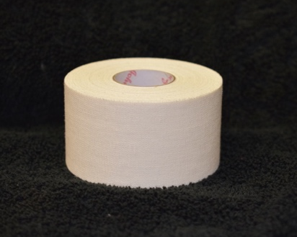 | FAKS01  $5.00/ROLL | Trainers Tape (J&J)  1.5” X 15YDS
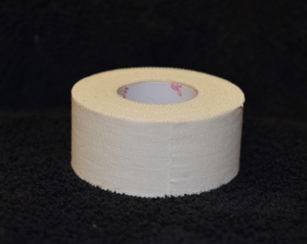 | FAKS122  $2.75/ROLL | Trainers Tape (Renfrew)  1” X 10 YDS
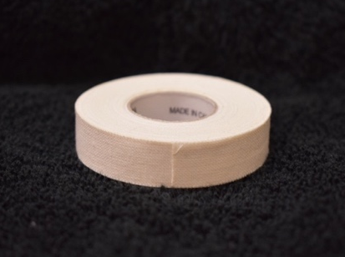 | FAKS87  $2.00/ROLL | Trainers Tape (Renfrew)  0.5” X 10 YDS
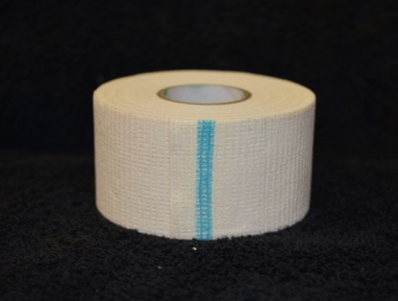 | FAKS143  $2.75/ROLL | Powertape (Andover)  1.5”
 | FAKS144  $5.00/ROLL | Powerflex Tape (Andover)  3”
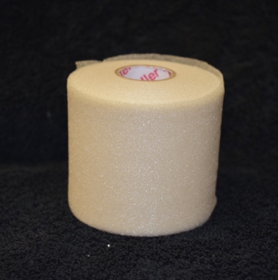 | FAKS09  $2.00/ROLL | Underwrap (Prowrap)  3” X 30 YDS
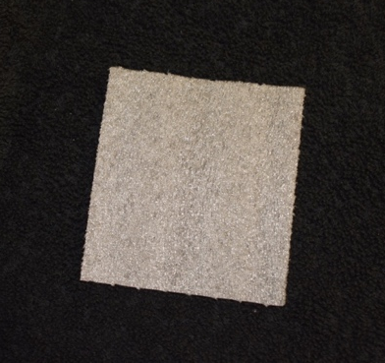 | FAKS14  $0.05/SQUARE | Heel and Lace Pad
 | FAKS02  $5.00/ROLL | Elastic Adhesive Tape  (Tensosport)  2” X 5 YDS
 | FAKS03  $7.75/ROLL | Elastic Adhesive Tape  (Tensosport)  3” X 5 YDS
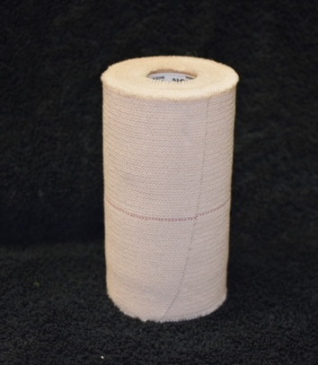 | FAKS04  $15.00/ROLL | Elastic Adhesive Tape  (Elastikon)  4” X 5 YDS
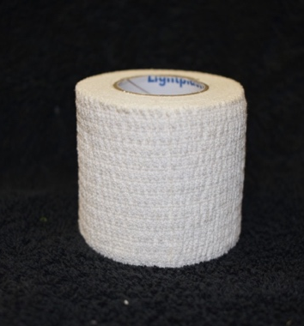 | FAKS05  $4.50/ROLL | Lightplast Pro Tape  2” X 7.5 YDS
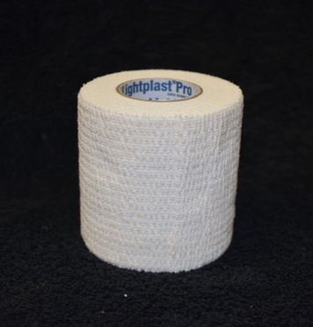 | FAKS06  $6.75/ROLL | Lightplast Pro Tape  3” X 7.5 YDS
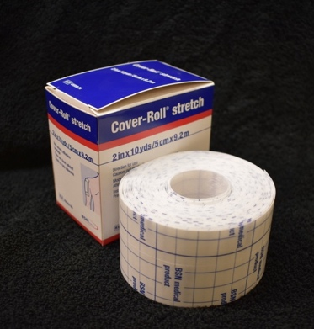 | FAKS51  $8.80/ROLL | Cover Roll Stretch Tape (Hypafix)  2” X 10 YDS
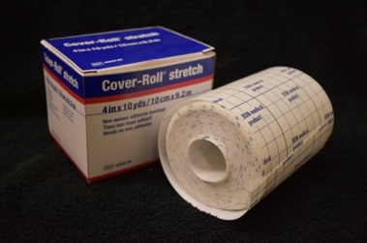 | FAKS103  $15.25/ROLL | Cover Roll Stretch Tape (Hypafix)  4” X 10 YDS
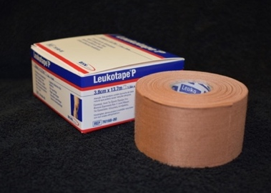 | FAKS89  $12.00/ROLL | Leukotape P  1.5” X 15 YDS
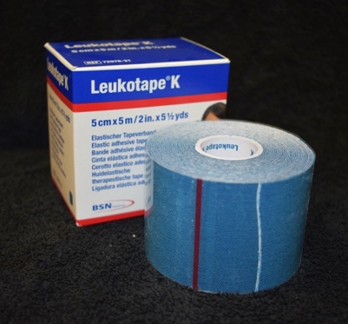 | FAKS98  $18.00/ROLL | Leukotape K  2” X 5.5 YDS
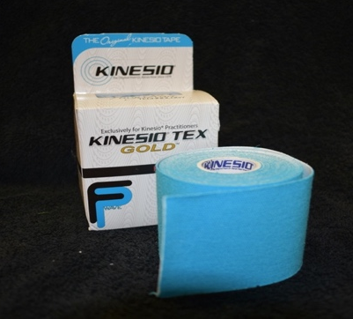 | FAKS129  $19.80/ROLL | Kinesio Tape  2” X 5.5 YDS
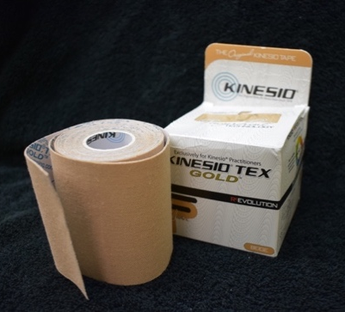 | FAKS130  $28.60/ROLL | Kinesio Tape  3” X 5.5 YDS
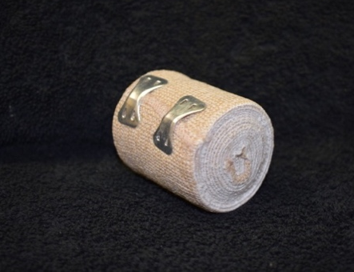 | FAKS22  $2.25/BANDAGE | Mid-Grade Elastic  Tensor Bandage  2” X 5 YDS
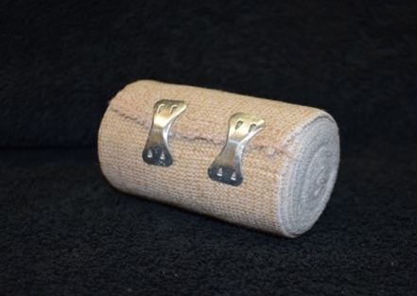 | FAKS23  $3.00/BANDAGE | Mid-Grade Elastic  Tensor Bandage  3” X 5 YDS
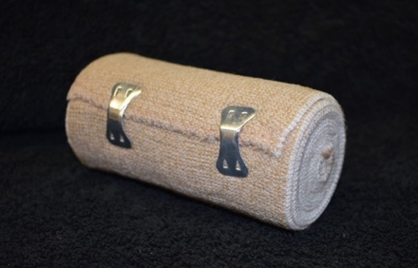 | FAKS24  $3.50/BANDAGE | Mid-Grade Elastic  Tensor Bandage  4” X 5 YDS
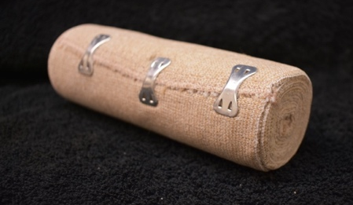 | FAKS25  $4.75/BANDAGE | Mid-Grade Elastic  Tensor Bandage  6” X 5 YDS
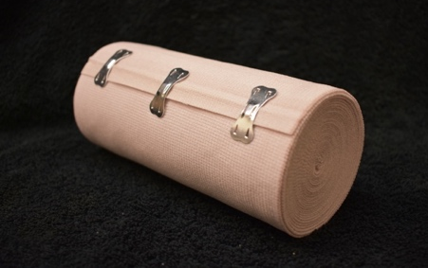 | FAKS26  $6.95/WRAP | Groin Tensor Wrap  (Mid-Grade)  6” X 10 YDS

PADDING
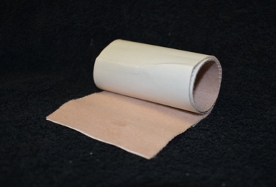 | FAKS88  $3.00/STRIP | Moleskin  3” X 12”
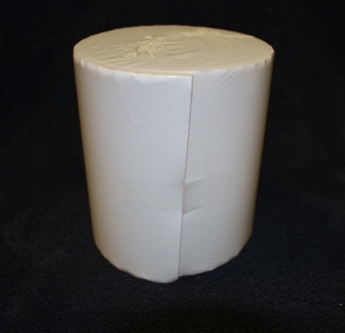 | FAKS07  $19.50/ROLL | Adhesive Foam Roll  1/8” X 5” X 2 YDS
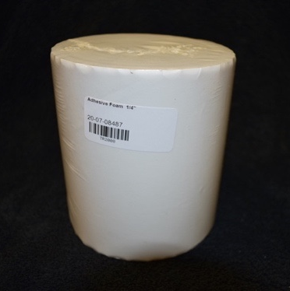 | FAKS08  $22.00/ROLL | Adhesive Foam Roll  1/4” X 5” X 2 YDS
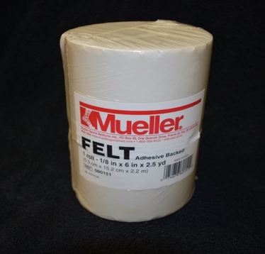 | FAKS127  $57.50/ROLL | Adhesive Felt Roll  (Mueller)  1/8” X 6” X 2.5 YDS
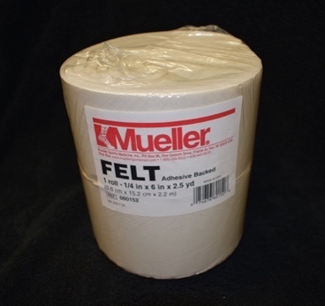 | FAKS128  $77.00/ROLL | Adhesive Felt Roll  (Mueller)  1/4” X 6” X 2.5 YDS
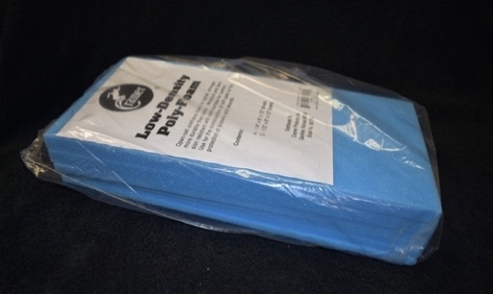 | FAKS65  $38.91/KIT | Low Density Foam Kit  (Cramer)  4 sheets- ¼”X 6”X12”  2 sheets- ½”X6”X12”
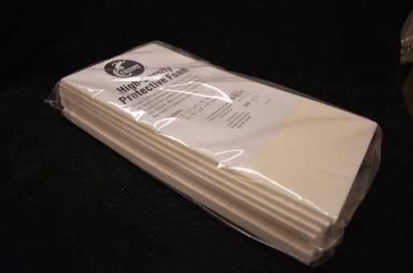 | FAKS66  $37.97/KIT | High Density Foam Kit  (Cramer)  4 sheets- ¼”X 6”X12”  2 sheets- ½”X6”X12”
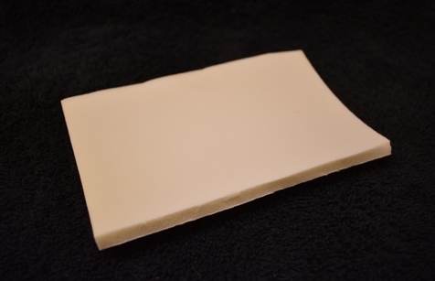 | FAKS96  $2.95/PIECE | Foam (Adhesive)  3” X 5” X 1/4”-1/8”
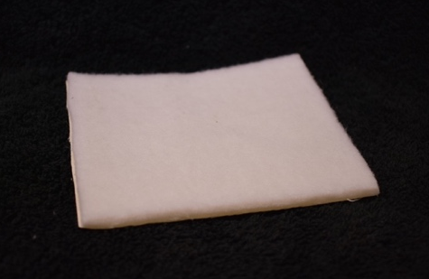 | FAKS97  $3.95/PIECE | Felt (Adhesive)  3” X 4” X 1/4”-1/8”
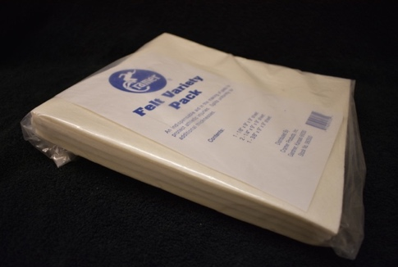 | FAKS64  $56.71/PACK | Felt Variety Pack  (Cramer)  4 Pieces (9” X 9”)  1 - 1/8”  1 – 3/8”  2 – 1/4"

FIRST AID
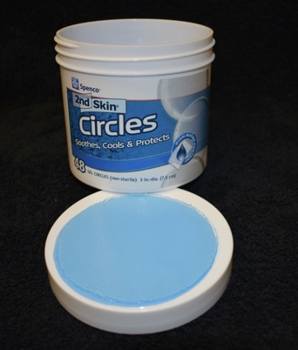 | FAKS10  $1.50/CIRCLE | Second Skin  3” Circle
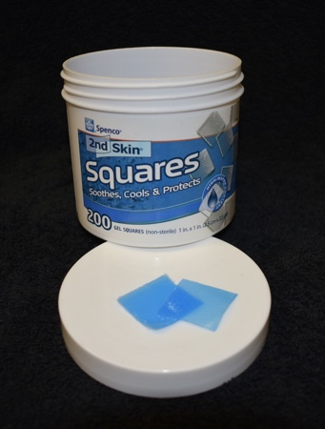 | FAKS95  $0.30/SQUARE | Second Skin  1” Square
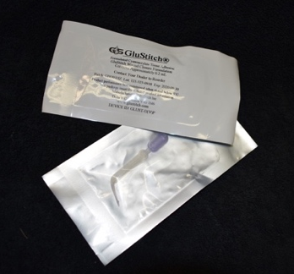 | FAKS120  $11.00/VIAL | Glu-Stitch  Tissue Adhesive  0.2ml Vial
 | FAKS132  $10.00/BOTTLE | Foot Powder  (Mueller)  4 OZ
 | FAKS111  $9.30/BOTTLE | Solarcaine  Medicated Lotion for Relief of Burns, Cuts & Bites  170ml
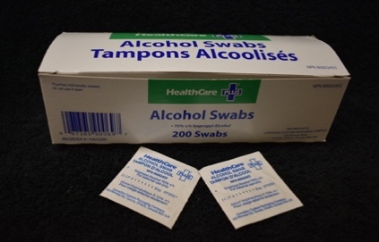 | FAKS83  $0.05/WIPE | Alcohol Prep Wipes
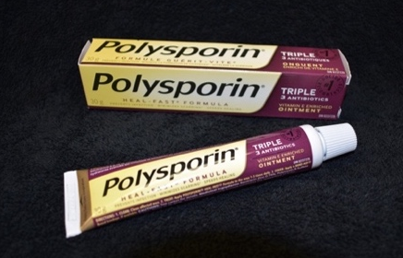 | FAKS82  $15.85/TUBE | Antibiotic Ointment  (Polysporin)  30g Tube
 | FAKS131  $2.50/BOTTLE | Sterile Saline  Sodium Chloride 0.9%  4 OZ
 | FAKS126  $3.05/BOTTLE | Isagel  115ml
 | FAKS141  $14.20/BOTTLE | Isagel  621ml
Photo Unavailable | FAKS108  $17.00/CAN | Antibacterial Waterless Foam Soap  (Cramer)  5 OZ
 | FAKS315  $8.80/CAN | Antibacterial Waterless Foam Soap  (Mueller)  4 OZ
 | FAKS55  $1.65/BANDAGE | Triangle Bandage  Arm Sling
 | FAKS56  $0.10/PIN | Safety Pin
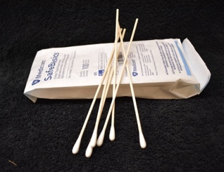 | FAKS84  $0.05/STICK | Cotton Tipped Applicator  6” Non-Sterile
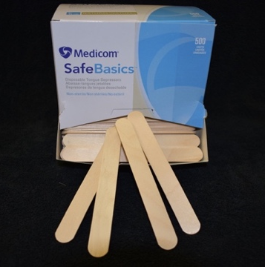 | FAKS52  $0.05/STICK | Tongue Depressor  Non-Sterile
 | FAKS110  $0.20/PLUG | Nasal Plug
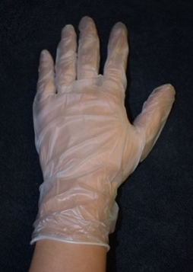 | FAKS45  $0.40/GLOVE PAIR | Vinyl Gloves Powder Free  (Aurelia Delight)  SM,MED,LAR,XL  1 pair
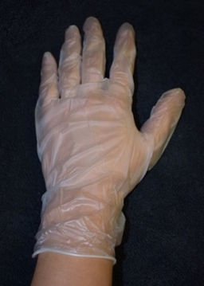 | FAKS44  $0.30/GLOVE PAIR | Latex Gloves Powder Free  (Aurelia Vibrant)  SM,MED,LAR,XL  1 pair
 | FAKS146  $11.80/BOX | Vinyl Gloves Powder Free  (Aurelia Delight)  SM,MED,LAR,XL  Box of 100 Gloves
 | FAKS147  $12.00/BOX | Latex Gloves Powder Free  (Aurelia Vibrant)  SM,MED,LAR,XL  Box of 100 Gloves
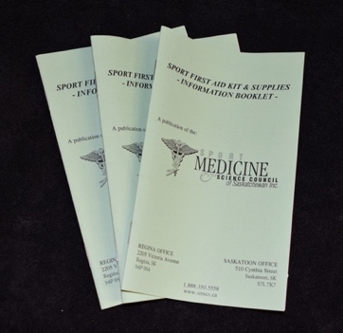 | FAKS150  $2.50/BOOKLET | Mini Sport 1st Aid Booklet
ATHLETIC SPRAYS
 | FAKS16  $9.31/CAN | Tape Adherent  (Mueller)  4 OZ
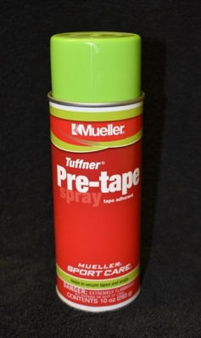 | FAKS76  $13.50/CAN | Tape Adherent  (Mueller)  10 OZ
 | FAKS93  $11.16/CAN | Tape Dehesive/Remover  4 OZ
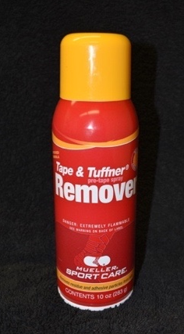 | FAKS92  $15.70/CAN | Tape Dehesive/Remover  10 OZ
Photo Unavailable | FAKS125  $24.40/CAN | Cold Spray  6 OZ
 | FAKS133  $25.85/CAN | Opsite Spray  Spray-On Wound Dressing  100ml

HOT & COLD PACKS
 | FAKS12  $4.00/PACK | Hot/Cold Pack  Re-usable (Medi-temp)  5” X 10”
 | FAKS13  $1.95/PACK | Instant Cold Pack
 | FAKS63  $.030/BAG | Ice Baggies (Ziplock)  8” X 10”

BANDAGES
 | FAKS27  $0.15/BANDAGE | Regular Bandaid  (Coverlet)  1” X 3”
 | FAKS28  $0.20/BANDAGE | Patch Bandaid  (Coverlet)  1.5” X 2”
 | FAKS29  $0.25/BANDAGE | Patch Bandaid  (Coverlet)  2” X 3”
 | FAKS30  $0.20/BANDAGE | Knuckle Bandaid  (Coverlet)  1.5” X 3”
 | FAKS31  $0.20/BANDAGE | Digit Bandaid Small  (Coverlet)  2-1/8” X 1.5”
 | FAKS32  $0.25/BANDAGE | Digit Bandaid Large  (Coverlet)  2.5” X 2”
 | FAKS33  $0.20/BANDAGE | Butterfly Wound Closure Bandaid
 | FAKS35  $0.65/BANDAGE | Eye Bandaid  (Opticlude)  Child
 | FAKS36  $0.65/BANDAGE | Eye Bandaid  (Opticlude)  Adult
 | FAKS37  $1.75/PACK | Steri-Strip Skin Closure Bandaid  1/8” X 3”  Package of 5
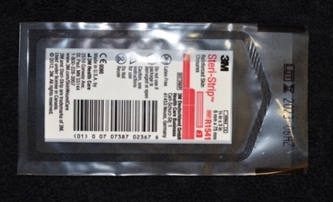 | FAKS38  $1.75/PACK | Steri-Strip Skin Closure Bandaid  1/4” X 3”  Package of 3
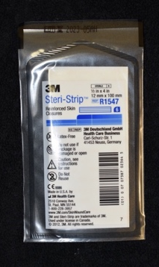 | FAKS39  $2.50/PACK | Steri-Strip Skin Closure Bandaid  1/2” X 4”  Package of 6
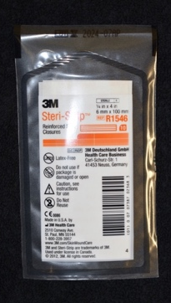 | FAKS106  $2.75/PACK | Steri-Strip Skin Closure Bandaid  1/4” X 4”  Package of 10

GAUZE
 | FAKS109  $0.33/PAD | Telfa Pad  Sterile Non-Adherent  3” X 4”
 | FAKS68  $0.25/PAD | Telfa Pad  Sterile Non-Adherent  2” X 3”
 | FAKS69  $0.15/PAD | Gauze Sponge  Sterile  (Medicom)  2” X 2”
 | FAKS70  $0.20/PAD | Gauze Sponge  Sterile  (Medicom)  3” X 3”
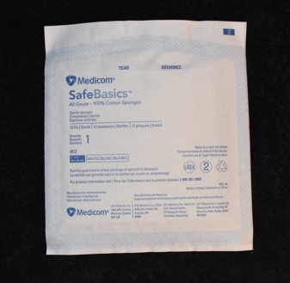 | FAKS71  $0.25/PAD | Gauze Sponge  Sterile  (Medicom)  4” X 4”
 | FAKS72  $0.06/PAD | Gauze Sponge  Non-Sterile  2” X 2”
 | FAKS73  $0.09/PAD | Gauze Sponge  Non-Sterile  3” X 3”
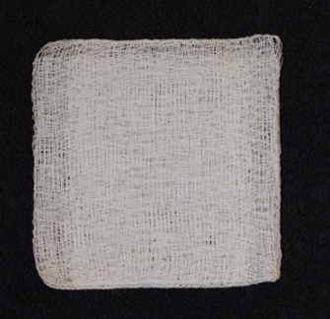 | FAKS74  $0.12/PAD | Gauze Sponge  Non-Sterile  4” X 4”
 | FAKS80  $1.35/ROLL | Conforming Gauze Bandage Roll  Sterile  4” X 4.4 YDS
 | FAKS99  $1.10/ROLL | Conforming Gauze Bandage Roll  Sterile  3” X 4.4 YDS

INSTRUMENTS/HARDWARE
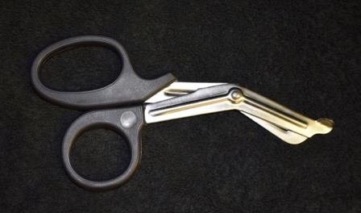 | FAKS62  $11.25/SCISSOR | Universal Scissor  High Grade  7”
 | FAKS41  $7.95/SCISSOR | Tape/Bandage Scissor  (Lister)  7-1/4”
 | FAKS42  $8.50/CUTTER | Zip Cut Tape Cutter
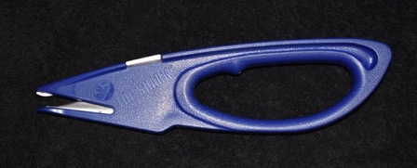 | FAKS43  $23.00/CUTTER | Shark Tape Cutter  (Cramer)
 | FAKS46  $1.60/BLADE | Zip Cut Replacement Blade
 | FAKS47  $7.30/BLADE | Shark Replacement Blade
 | FAKS40  $4.40/LIGHT | Pen Light
 | FAKS50  $1.95/TWEEZER | Splinter Forcep/ Tweezer  4”
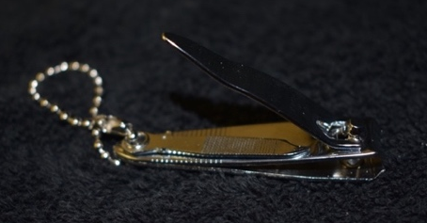 | FAKS86  $2.50/CLIPPER | Finger Nail Clipper
 | FAKS53  $4.75/CLIPPER | Toe Nail Clipper
 | FAKS54  $0.55/RAZOR | Disposable Razor
 | FAKS124  $3.85/BLANKET | Emergency Blanket  51” X 82”
 | FAKS308  $27.50/PAIR | Crutches Aluminum  Youth  4’6” – 5’2”
 | FAKS313  $27.50/PAIR | Crutches Aluminum  Medium Adult  5’2” – 5’10”
 | FAKS314  $27.50/PAIR | Crutches Aluminum  Large Adult  5’10” – 6’6”
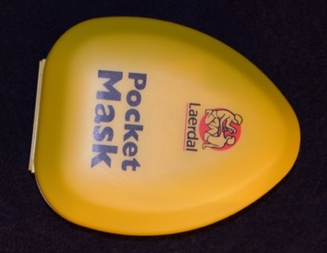 | FAKS81  $27.00/MASK | CPR Pocket Mask  With Oxygen Valve

BALMS/LUBE/GEL
 | FAKS67  $6.15/JAR | Analgesic Ointment/ Atomic Balm  (Cramer)  3 OZ
 | FAKS102  $38.00/JAR | Analgesic Ointment/ Atomic Balm  (Cramer)  1 LB
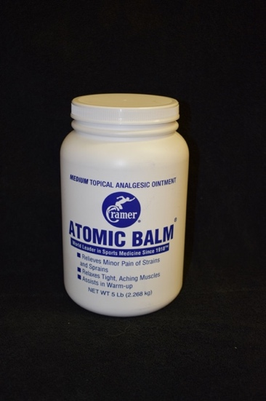 | FAKS113  $159.00/JAR | Analgesic Ointment/ Atomic Balm  (Cramer)  5 LB
 | FAKS105  $34.00/BOTTLE | Flexall 454 Rub  Extra Strength  16 OZ
 | FAKS123  $12.50/JAR | Deep Cold Pain Relief Gel  8 OZ
 | FAKS15  $3.75/JAR | Skin Lube  3 OZ
 | FAKS75  $20.00/JAR | Skin Lube  1 LB
 | FAKS114  $75.00/JAR | Skin Lube  5 LB
 | FAKS118  $19.65/BOTTLE | Massage Lotion  Biotane Advance Therapy  8 OZ
SPLINTS
 | FAKS77  $4.15/SPLINT | Finger Splint Aluminum  1/2" X 18”
 | FAKS78  $4.70/SPLINT | Finger Splint Aluminum  3/4" X 18”
 | FAKS79  $5.67/SPLINT | Finger Splint Aluminum  1" X 18”
 | FAKS104  $17.00/SPLINT | SAM Splint  4” X 36”
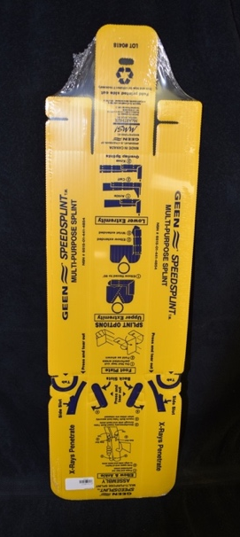 | FAKS94  $15.50/SPLINT | Quick (Speed) Splint  Multi-Purpose Limb Splint

FRIST AID KIT (STOCKED & EMPTY)
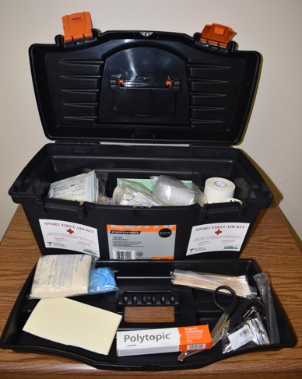 | FAK02  $160.00/KIT | Standard Sport First Aid Kit  Fully Stocked  -Container included  *Full list of contents on our website under 1st Aid Sales drop down
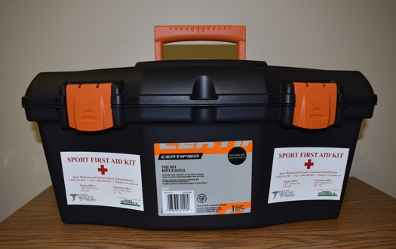 | FAKS115  $22.65/CONTAINER | Standard Sport First Aid Kit Container  *No additional supplies included

EXERCISE/REHAB EQUIPMENT
Photo Unavailable | FAKS134  $140.00/ROLL | Thera-Band Exercise Band  50 YDS - Latex Free  Red (Medium)
Photo Unavailable | FAKS135  $160.00/ROLL | Thera-Band Exercise Band  50 YDS - Latex Free  Green (Heavy)
Photo Unavailable | FAKS136  $175.00/ROLL | Thera-Band Exercise Band  50 YDS - Latex Free  Blue (Extra Heavy)
Photo Unavailable | FAKS137  $195.00/ROLL | Thera-Band Exercise Band  50 YDS - Latex Free  Black (Special Heavy)
Photo Unavailable | FAKS145  $235.00/ROLL | Thera-Band Exercise Band  50 YDS - Latex Free  Silver (Super Heavy)

