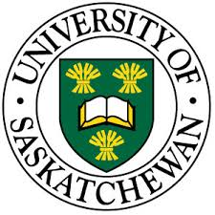
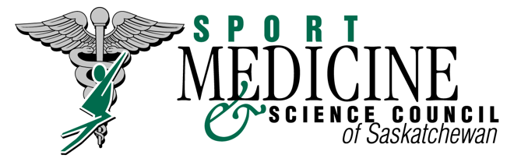

Sport Safety Program

Application to Receive Recognition of Program Equivalency

University of Saskatchewan - College of Kinesiology

Students enrolled in the University of Saskatchewan - College of Kinesiology, will be eligible to receive equivalency for the Sport Medicine and Science Council of Saskatchewan’s Sport Safety Program Certificate of Program Completion.
(Please Provide Proof of Completion: unofficial transcripts and certificates of course completion in order to be approved for the equivalency program)

- They have successfully completed the following courses with a passing grade:
________ ANAT 221 - Gross Anatomy
________ KIN 121 – Functional Effects of Physical Activity
________ KIN 225/226 – Introductory Exercise Physiology 1 & 2
________ KIN 321 – Prevention & Care of Sports, Recreation, & School Injuries

- They have successfully completed the following courses:
________ Standard First Aid (St. John’s or Red Cross)
________ CPR (either A, B, or C)

- They pay the appropriate fee to the SMSCS.
*Will be contacted for payment once your application has been approved
________ Sport Safety Program Fee ($30.00)

* This will be a one-time fee. This certification is valid for 4 years after it has been awarded. At that time, you will be required to take our Sport Taping & Sport 1st Aid Workshops to maintain this certification

Permanent Address of Application: (A Certificate will be mailed out)

Name: (please print) _____________________________________________________________

Address: _____________________________________ City: ____________________________

Postal Code: _________________________ Phone: ___________________________________

Email: ___________________________________________ Date: _______________________

